

Pallavi Kale X19183461

C H

R.G.

L.P

Pallavi Kale X19183461

Cheong Hao Io X19220456

Rosana Gomez X19223641

Lakshmi Parisa X19212968

**Global Food Emission & GDP**

Between 2000 – 2020

Data Visualisation CA 2



Table of Contents

1. Introduction 5

1.1. Research Questions 5

1.2. Dataset description 6

1.3. Data Preparation 7

1.3.1. Software Tools used for analysis 9

1.3.2. Timeline visualisation 10

1.4. Analysis 11

1.5. Findings 20

1.6. Conclusion 21

2. Appendix 22

2.1. Infographic 22

2.2. Major benefits 22

3. Bibliography 29

**List of Figures**

Figure 1. Units vs Items 6

Figure 2. Original GPD dataset overview 7

Figure 3. Original food emission dataset overview 8

Figure 4. Original GPD dataset 8

Figure 5. Filtered years 8

Figure 6. Melting data into one column 9

Figure 7. Merged and pre-processed dataset 9

Figure 8. GDP by World Regions 10

Figure 9. CO2 emissions in Gigagrams by Continent and Product 10

Figure 10. Dashboard 1 12

Figure 11. Dashboard 2 13

Figure 12. Dashboard 3 14

Figure 13. Dashboard 5 16

Figure 14. Dashboard 6 17

Figure 15. Dashboard 7 18

Figure 16. Infographic cover page …………………………………………………...… 24

Figure 17. Top 3 countries GDP and carbon emissions info …………………...…… 25

Figure 18. Agriculture emission ………………………………………………………….25

Figure 19. Cattle product emission …………………………………………………….. 26

Figure 20. Cereal production emissions ………………………………………………. 26

Figure 21. Rice production emissions …………………………………………………. 27

Figure 22. Fresh cow milk production emissions ………………………………..…… 28

Figure 23. Fresh buffalo milk production emissions ………………………………….. 28

Figure 24. Egg production emissions ……………………………………………..…… 29

Figure 25. Pork Meat production emissions …………………………………...……… 30

**List of Abbreviations**

**CSV** Comma Separated Values

$${CO}_{2}^{}$$

Carbon di oxide

$${CH}_{4}^{}$$

Methane

**R** Programming language used for statistical computing and graphics.

**IT**  Information Technology

**MS Excel** Microsoft Excel

$${NO}_{2}^{}$$

Nitrous Oxide

**GDP**  Gross domestic product

**GHG**  Green House Gases

**FAO** Food and Agriculture Organisation

# Introduction

Since the start of the industrial era in the 18th century there has been an increase in amount of poisonous gases released into atmosphere. Gases like nitrous oxide, methane, Fluorinated Gases, chlorofluorocarbons, carbon dioxide (CO2) are released in the atmosphere compared to pre-industrial times. Industrialization led to population growth and thus to a higher demand of food supply. Activities related to global food production such as agriculture and food processing are linked to emissions of greenhouse gases (GHG) such as Methane (CH4) and Nitrous oxide (NO2). On the other hand it is significant as well that the more industrialized a country is the higher its levels of GHG emissions are.

As well industrialization is connected to economic growth. In the course of the industrial age and as countries became more industrialized the demand for food increases as population growths. Consequently, the rise in food production increments the emissions of GHG. “Food production is responsible for one-quarter of the world’s greenhouse gas emissions”. (Ritchie and Roser, 2020)

## Research Questions

The aim of this project is to examine the relationship between food production, emissions and economic growth. For this purpose the suggested research is done. We have following research questions at the beginning of our analysis:

* Is there a relationship between greenhouse gases emissions and economic growth? And if so, what is the nature of this relationship?
* What food items are produced in higher amounts and what countries produce them?
* What type of food production is releasing the high amount of Greenhouse gases?

## Dataset description

The datasets considered for this analysis are “Environment_Emissions_intensities_E_All_Data” from the Food and Agriculture Organization of the United Nations website <http://www.fao.org/faostat/en/#data/EI/visualize>

The data is chosen from year 2000 to year 2017 and it contains 38000 records and 12

variables per different world regions or countries.

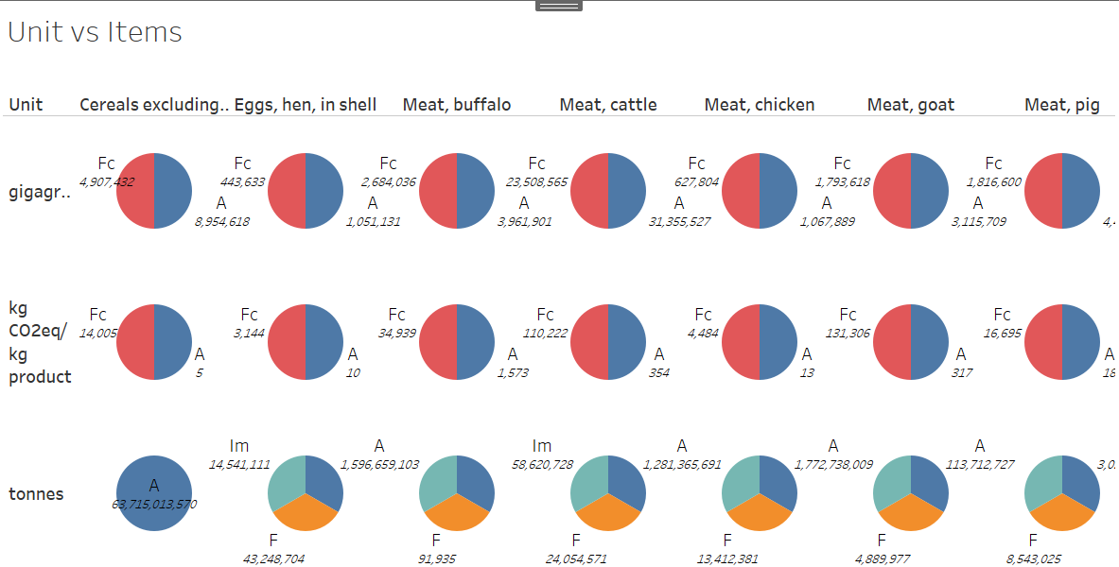

Figure 1. Units vs Items

The dataset is categorised into Production in tonnes per year, Emissions (CO2eq) measured in gigagrams and Emission Intensity measured in kg CO2eq/kg product.

The GHG emissions are measured for food items such as cereals, meat, milk and rice for all world countries. The variety of items is interesting as the dataset analyses different types of meat, milk and cereals which reflects the diversity of products by regions. GDP per capita growth (annual %)” from The World Bank website.

<https://data.worldbank.org/indicator/NY.GDP.PCAP.KD.ZG>

The GDP dataset shows the Gross Domestic Product (GDP) per country from between years 2000 and 2019. It contains 265 records that relate to countries. The GDP is measured in current US$. The evolution from year to year is clearly visible as countries increase and/or decrease their GDP levels. The period chosen for analysis, 2000 to 2019, reveals that Asia is the continent with the highest increase in GDP levels in the world during the XXI century.

Carbon emissions datasets is referred to get the figures on carbon emissions in tonnes and share of carbon emissions. The emission data is tracked from year 1850.

<http://www.globalcarbonatlas.org/en/CH4-emissions>

Similarly for referring to agriculture GHG emission data following website was accessed.

<https://www.climatewatchdata.org/data-explorer/historical-emissions?historical-emissions-data-sources=71&historical-emissions-gases=246&historical-emissions-regions=All%20Selected&historical-emissions-sectors=843&page=1>

## Data Preparation

There are two datasets have been used for this project, which represented the relationship from the overall GPD values and global emissions for each country.

1. GPD Value

This dataset contained all GPD values from 264 countries between the year of 1960 to 2029, there are 264 rows and 64 columns in total.

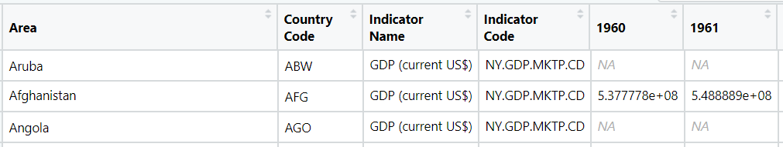

Figure . Original GPD dataset overview

1. Food Emission

This dataset contained all food emission related information between the year of 1961 to 2017, there are 383574 rows and 11 columns in total.

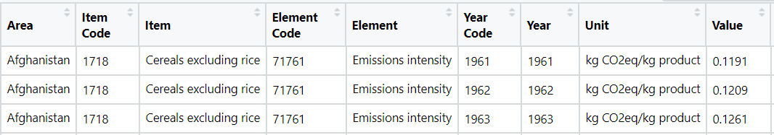

Figure . Original food emission dataset overview

Prior the actual data analysis process, data pre-processing is an essential step, which included process of data selection, tiding and cleaning etc. In this project, “RStudio” is selected to use for this step.

**Import file and review missing data**

First is to import both dataset files into the “Studio” working directory, next is check if there is any “NA” value existed for each dataset

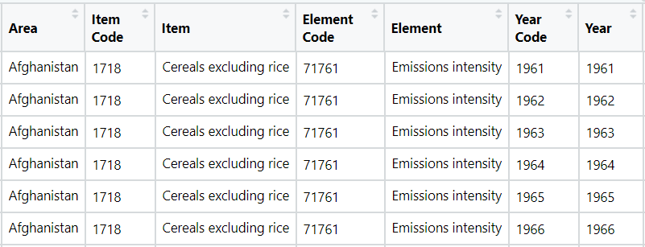

Figure . Original GPD dataset

**Data Selection**

As to follow the research objective, all year related data from 2000 to 2019 are selected and filtered.



Figure . Filtered years

**Tidy Data**

After selected the correct year range, next is to break down the years data and organise into one column, function “Melt” is used for this. where the cleaned dataset is keeping several related columns and assign all the years into a new column name “Year”.

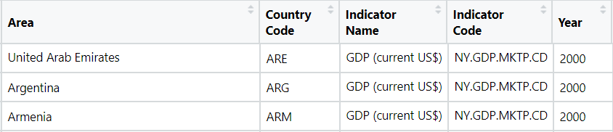

Figure . Melting data into one column

**Merging**

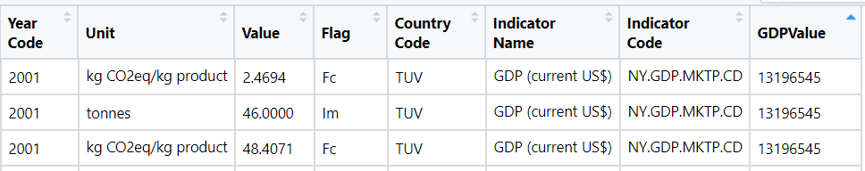

Figure . Merged and pre-processed dataset

After merging the file for saved in CSV format, but since the file had more than 60,000 rows it needed to be saved in Excel format so the whole file could be read.

### Software Tools used for analysis

Various software tools are used to produce the visualisation. For cleaning and merging file R Studio version 1.3.1056, Dashboard and story is created in Tableau 2020.2, Infographics are created using Canva. For generating a timeline video Flourish website has been used.

### Timeline visualisation

The GDP by World Regions Flourish visualisation compares the evolution of levels of GDP in the main world areas in the period 2000 – 2019.

<https://preview.flourish.studio/3392268/1CjoVK9Ty5e37P1XJG0YD1S-rO70-RXnIxrtNJtPB4bAluVhF1f1XSh1wW89JRw3/>

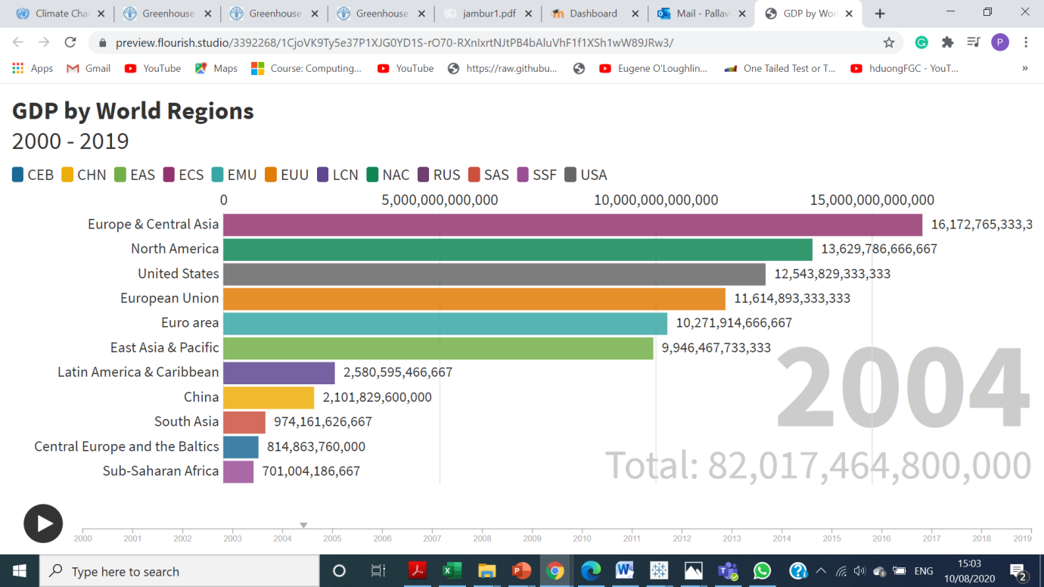

Figure 8. GDP by World Regions

The chart shows the timeline of food items and there emissions by continents for the period 2000 – 2017.

<https://app.flourish.studio/visualisation/3421548/>

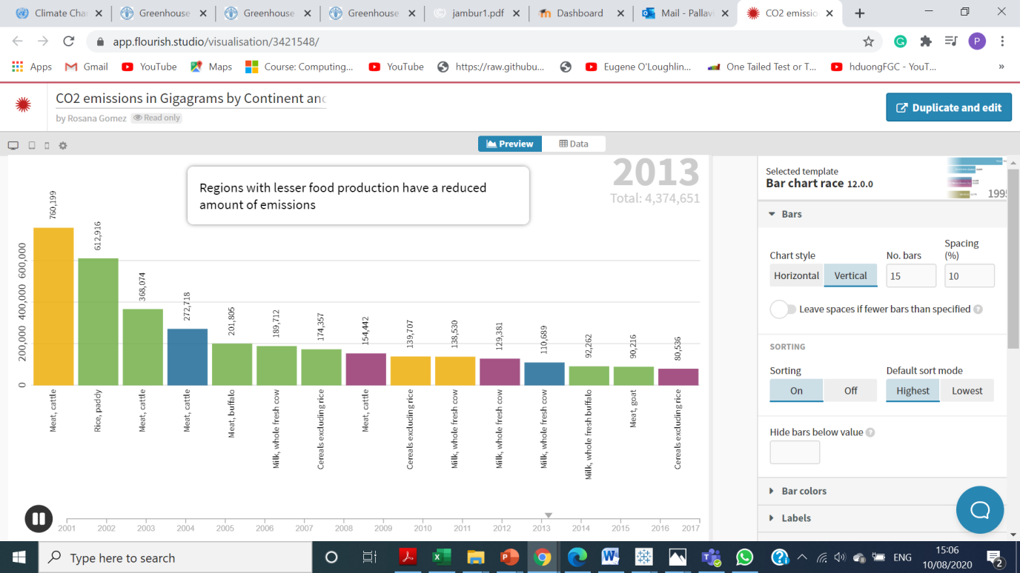

Figure 9. GHG emissions in Gigagrams by Continent and Product

## Analysis

We have done the analysis based on our research questions. Through the various Dashboards we will try to analyse our dataset and gain some meaningful insights.

***Design Choices:***

* Line charts have been used to create visualisation where data was showing a period of years and to represent various countries.
* The stacked charts (area charts) are used for depicting the composition of gases throughout the recorded history.
* Bubble and Tree map has been used to show a graphical representation of high emitters and high food producers.
* Use of geographical maps to show distribution of emission and production throughout the world.
* Animated scatter plots to show increase in emission levels with the passing of years.
* Embedded charts to display comparison among various emission intensities.
* Bar charts to compare GDP values with countries Emission levels.

***Choice of Colours:***

* A colour scheme of blue, green and red has been used across charts as it represents the agricultural & emission levels. The use of red colour to draw attention to specific areas which need attention.
* The numbers have been coloured and increased in size appropriately to draw attention to details.
* Across all charts the unneeded information has been removed or mutated to draw attention to only specific details.
* The charts are plotted against a white background to reduce unnecessary visual noise.

**Dashboard 1**

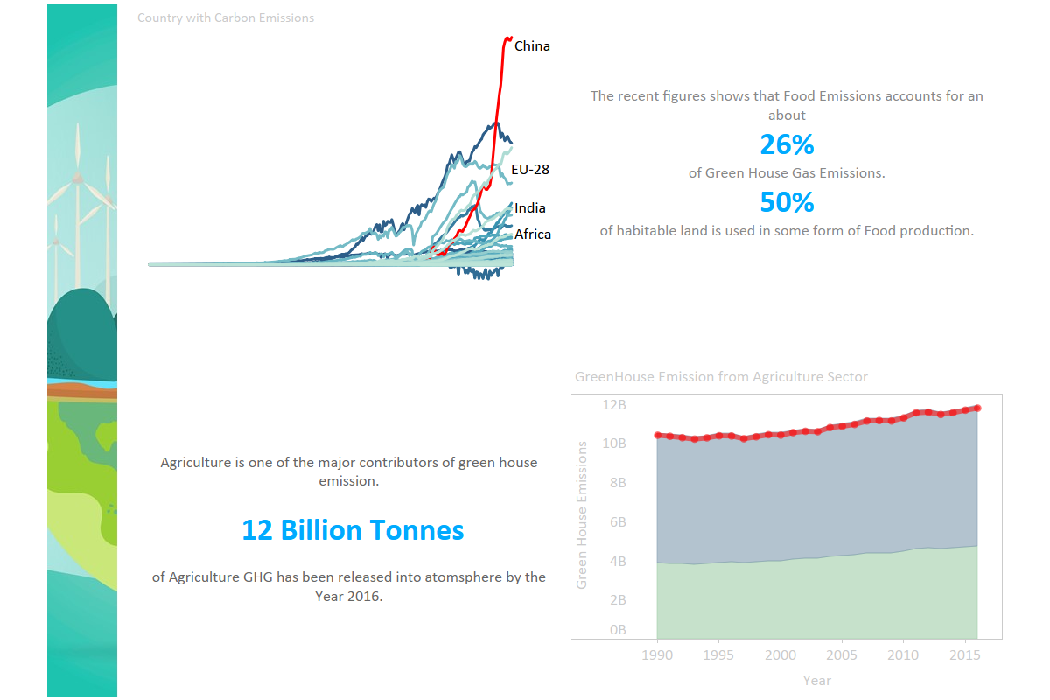

Figure 10. Dashboard 1

According to the given information from Dashboard 1, the highlighted red colour on the upper left layer is pointing out China is the highest carbon emissions releasing country in the globe, where is taking about 27.5 % of the total carbon emissions from each year.

Apart from that, food emissions are taking up to 26% of the overall greenhouse emissions matter. In fact, there are 50% of the habitable land is used for the purpose of agriculture.

In the lower section, data is showing that agriculture is playing a main role in greenhouse emissions, where there were 12 billion tonnes of GHG had released into atmosphere by the year of 2016. There is also a graph on the lower right, where showing the breakdown green emissions level from agriculture sectors and the figures are continuously and positivity growing to a larger amount.

**Dashboard 2**

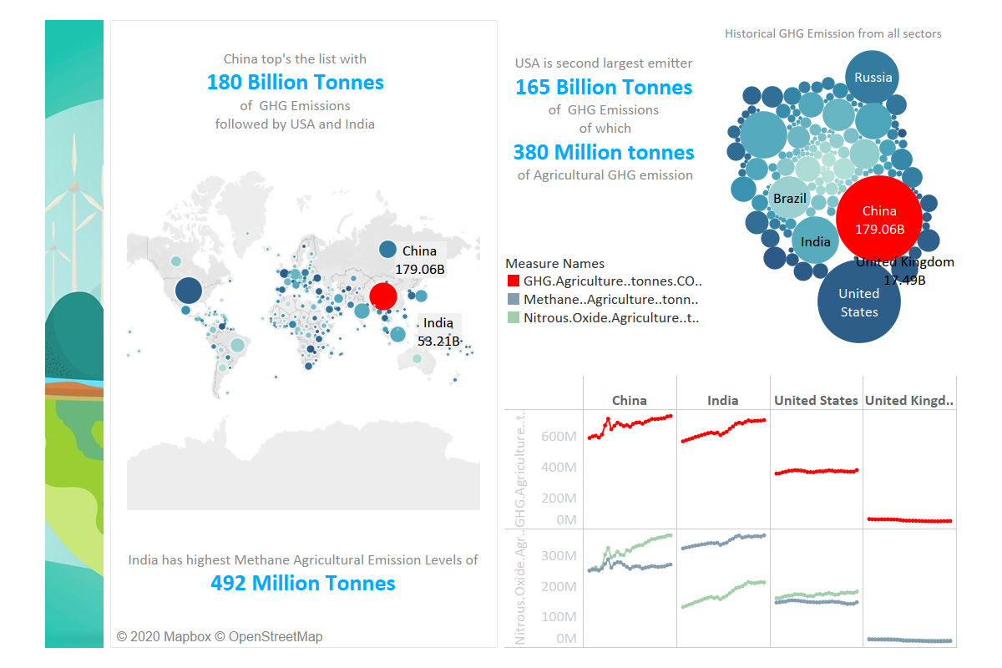

Figure . Dashboard 2

Dashboard 2 gives an overview of the highest amounts of greenhouse gases (GHG) emissions in the world. China, India and the United States are the main contributors of GHG emissions.

The Green House Gas Emissions Map displays the tonnes in billions of the total emissions in the world map. This is quite visual and makes it easy to understand the comparison between countries around the globe. Obviously the main producers of emissions are the biggest countries by area. These countries need to feed their population as well as export their products. The higher the country population is the more agricultural items they need. China and India, by being the most populated countries in the world; they are also the highest GHG emissions creators.

In the Historical Green House Emission chart China and the United States appear as the main historical emitters of GHG emissions by billions of tonnes most of which belong to agricultural emissions. Although the population between the two countries differ substantially the amount of emissions is quite similar. This indicates that the United States emissions per capita have been considerably higher than those in any other country. “In 2017, global carbon dioxide emissions from fuel combustion reached 32.8 billion tons in 2017 according to the [International Energy Agency](http://energyatlas.iea.org/#!/tellmap/1378539487). [China](https://worldpopulationreview.com/countries/china-population), the largest contributor, was responsible for 28% of these emissions, followed by the [United States](https://worldpopulationreview.com/countries/united-states-population) (14%)” (Greenhouse Gas Emissions By Country 2020, 2020).Russia, India and Brazil follow the list of historical emitters as well as the United Kingdom although its area is significantly smaller.

The Countries with High Green House Emission chart supports the data shown in the previous two charts. China, India and the United States are by far the highest emitters in the world. The main type of emissions is those produced by agricultural items.

**Dashboard 3**

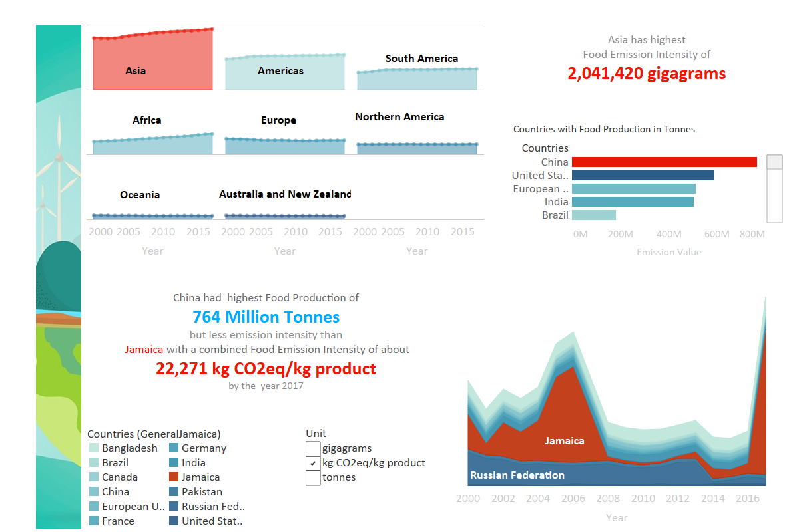

Figure . Dashboard 3

Dashboard 3 represents the vast amount of emissions expelled into the atmosphere from food. The emission released is divided into the 7 different continents for the first graph. The data is recorded over a period of 17 years. In this time period Asia was, and still is, the highest contributor followed by Americas. The unit used, to measure the intensity, was gigagrams. In 2017 Asia’s emission value was at a whopping 2,041,422 gigagrams and the Americas at 1,181,274 gigagrams. Australia and New Zealand having the lowest emission value in 2017 at 124,788 gigagrams. China had the highest food production levels of 764 million tonnes followed by USA.

Jamaica is recorded to have highest emission intensity of 22,271 kg CO2eq/kg product in the recorded history. Canada had the lowest emission value out of the selected countries with an emission value of only 35, which is the all-time highest for Canada.

The kg CO2eq/kg product is a ratio which is obtained by dividing the production in tonnes by emissions (CO2eq) measured in gigagrams. CO2 eq is the measure of any gas in terms of carbon dioxide equivalent. This is a common scale of measuring any gas to warm the earth’s atmosphere.

**Dashboard 4**

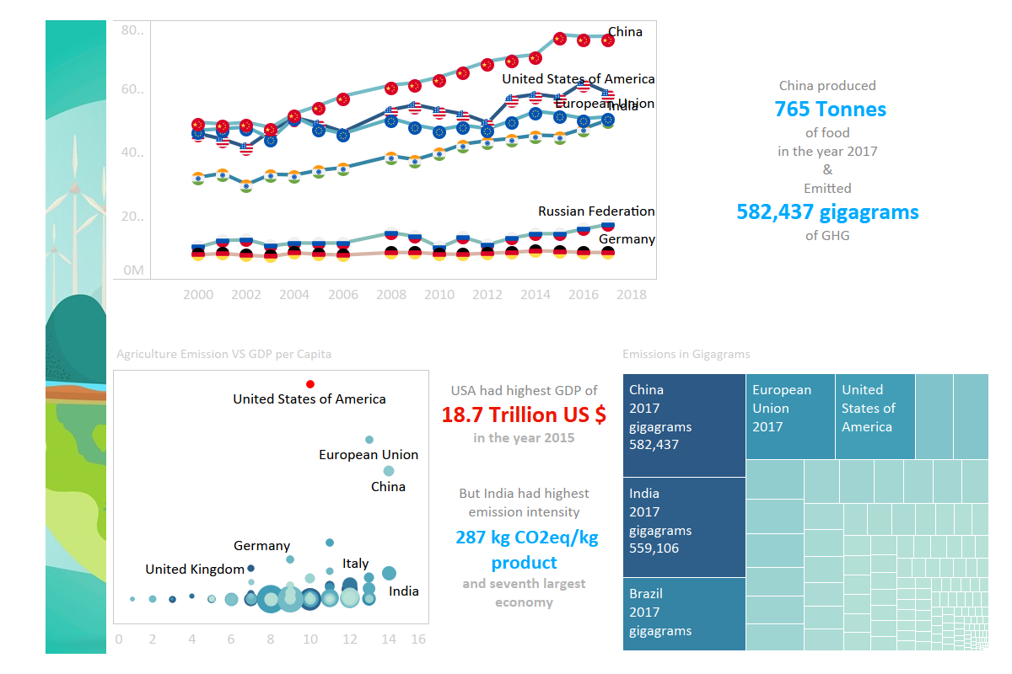The line chart shows the food producing countries, in the span of 17 years China has been at forefront of food production, followed by USA and India. The Tree map shows the distribution of food emissions in 2017 with China and India occupying top spots.

Figure 13. Dashboard 4

Scatter plot of Emission VS GDP shows USA as the largest economy of 18.7 Trillion US$ but China and India have high emission intensity than USA.

**Dashboard 5**

Figure 13. Dashboard 5

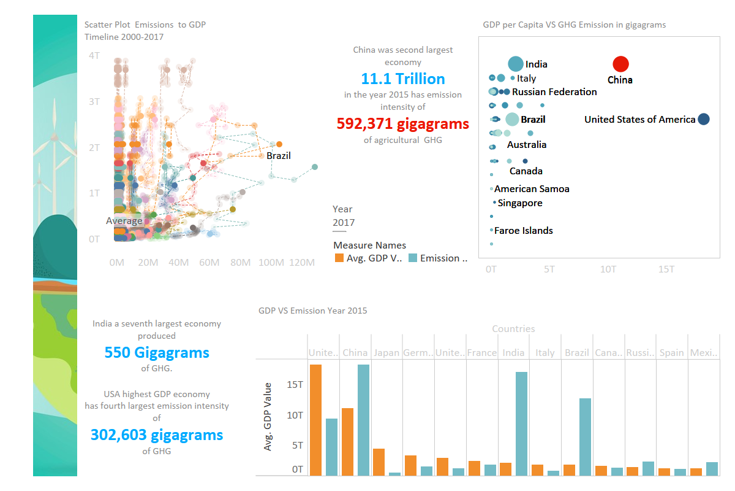

Dashboard 5 deals with Emission and GDP values. A scatter animated plots shows emission values for countries with low GDP and emission based on items such as meat,paddy,milk.

A scatterplot of GDP to Emission shows an increase in emission levels for second and seventh largest economies, but other countries like Brazil, Itlay,Russia and Germany too have a higher emissions than USA.This is an alarming sitiuation as the countries have low population and income levels than USA have high emission rates. Even countries like Indonesia, Myanmar, Japan, Mexico,Turkey,Ethiopia and many others with lesser GDPs have high emission levels.

Column chart for comparing the GDP & Emission levels give a very specific insight of how world econmies are behaving and what could be future prediction levels.Apart from China and USA, India and Brazil are gaining attention because of high emission levels.

**Dashboard 6**

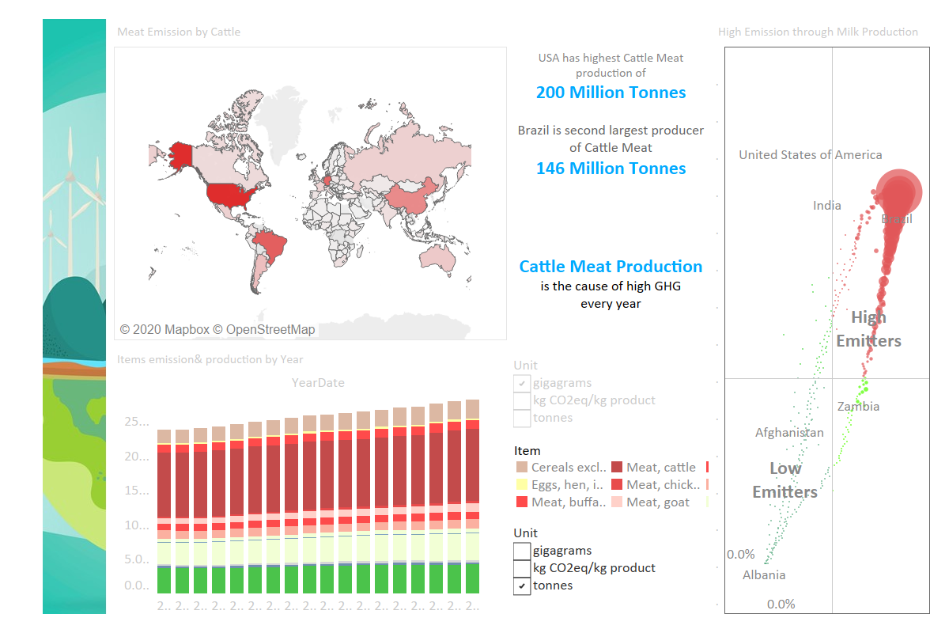

Figure 14. Dashboard 6

Dashboard 6 has been designed to give a detail insight into various food items and their role in GHG emission from extensive farming. The geographical map is an interactive map which presents user with the highest Cattle meat consuming countries. USA and Brazil are highest producer and consumers of cattle meat, followed by China and EU countries.

An emission plot showing high and low emitters bewtween year 2014 and 2015, based on their rank percentage.The countries are divided in four quadrants with high,low and medium emitters.

An interactive bar chart of food items between Year 2000 to 2017, presents with a grime reality that Cattle methane emission levels are highest in the atomsphere, followed by rice and chicken production.

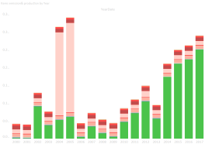

However a chart of Emission intensity gives an interesting insight that kg CO2eq/kg product of Rice/Paddy has been highest between 2014 to 2017, whereas Goat meat had high emission intensity in year 2004 and 2005.

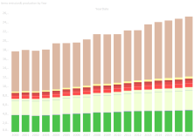

Production of cereals excluding rice is on the top list of food items produced every year, while rice and chicken production are second and third largest respectively.

***Colour scheme:*** The food items have been assigned colours based on their colour in nature like Meat has been assigned colour red and other hues for depicting other sources of meat, Rice has been assigned green, eggs light yellow and cereals are assigned brown.

**Dashboard 7**

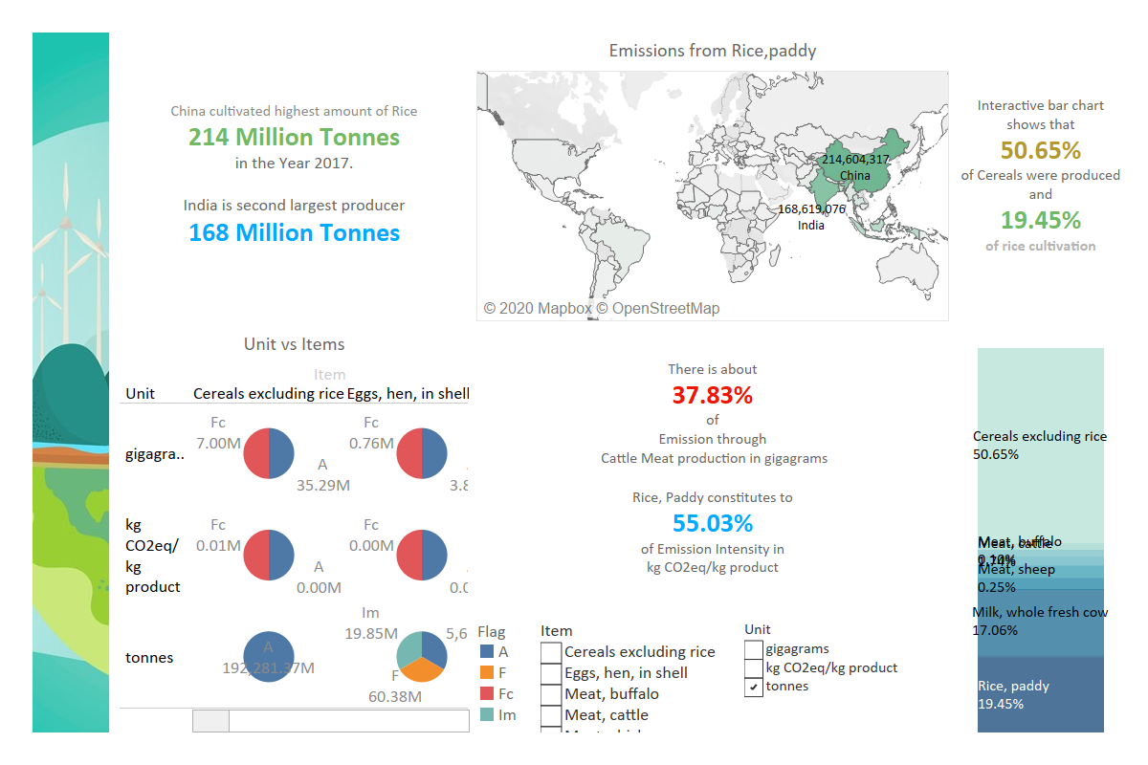

Figure 15. Dashboard 7

The Dashboard 7 is designed around food items, the interactive map shows all the food items listed in Items category. Rice/Paddy is produced largely in countries like china and India, this could be as a result of the cultural food habits, favorable climate and huge populations explosion.Aside from rice/paddy we can also see other food articles such as milk, chicken, cereals and meat.

The pie charts presents Unit VS Items plot. It explains the difference between food products, including cereal, egg, meats of buffalo, cattle, chick and pork and Unit data which is delivered on the left bar, such as overall emissions in gigagrams, each kg’s production and its CO2 emission value, and production in tonnes.

The interactive bar chart shows the percentage of food production for a period of 17 years. Cereals accounts for 50.65%, while rice and Milk production is 19.45% and 17.06% respectively.

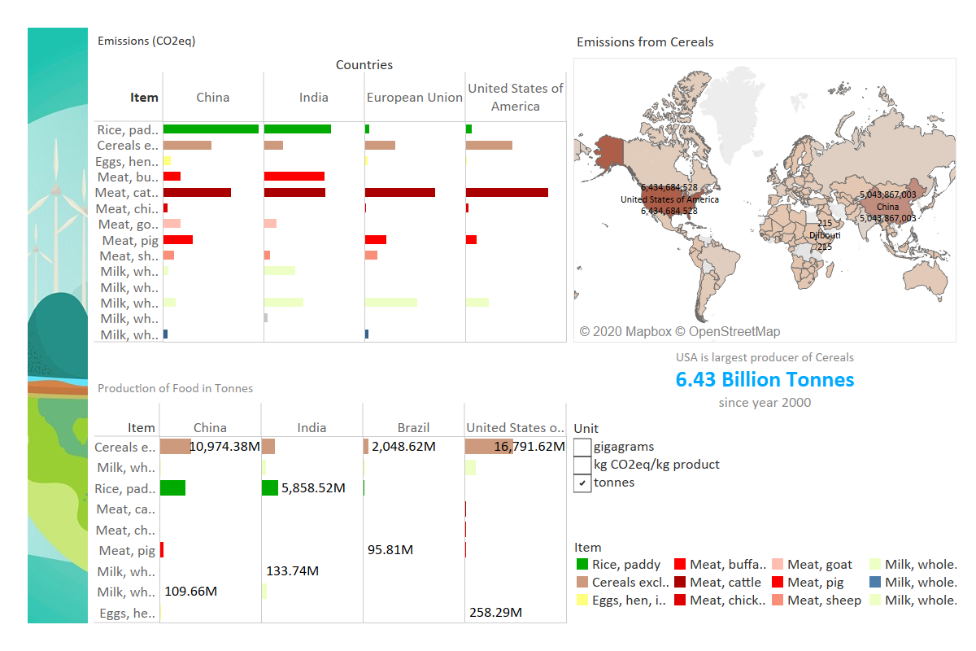

Figure 16 Dashboard 8

This dashboard shows the production of cereals around the world, the bar chart compares the highest emitting countries based on items category.In China and India high emissions are from Rice/Paddy, whereas in USA &EU the emissions are from Cattle meat and Cereals, this confirms the eating habits of people.

The other bar chart too compares the production levels in Brazil,China,India and USA. Interestingly the production of cattle meat is low but the emission rates are high for USA.This calls for population attention in improving there food habits.

## Findings

A detailed analysis was done on various datasets so that a comprehensive understanding of the subject can be gained. Though the subject is widely known throughout the world, but as a Data Analyst student it was a great learning to see how the data can be modelled to gain insights. some of the findings through our analysis are listed below:

## The rise in emission levels has been as a result of massive production of goods and items.

1. Agriculture food emissions accounts for 26% of overall GHG emissions.
2. Developed countries with high GDP and high population levels are at the forefront of high emission levels.
3. The emission levels have a correlation ship with high GDP, like USA and China two topmost GDPs have high food production and emission levels.
4. Developing countries like India with seventh GDP has high production, emissions and emission intensity. These figures are alarming for the world.
5. A research suggests that India has severely taxed its water resources and could face huge crisis as a result of massive exploitation of resources.

Countries with low GDP have high emission intensity in terms of kg CO2eq/kg product. What does that mean is, these economies are producing high levels with their food production and emission levels though they are small on the map.

1. Asia is the largest contributor of GHG and Australia and New Zealand are the lowest.
2. Food products, such as rearing of cattle for meat production is the cause of high methane emissions in the atmosphere. It is a known fact that methane and NO2 are more harmful for earth’s atmosphere than Carbon dioxide. If the same pace is kept it could be a major downfall factor for our air quality.

Numerous studies have shown the ill effects of methane and NO2 if we keep on consuming at the same rate. The use of alternative options, like switching to vegetarian diet or alternative meat sources is suggested by many experts.

1. Though rice is a vegetarian food product but it has been a leading item for high food emission intensity in the last 10 years.
2. Rearing of cows, buffalo for milk and dairy products also is the cause of GHG emissions.

## Conclusion

The graphical representation of data provides a tremendous insight into the trends and patterns which could not be gained through study of numbers. The raw data which we modelled to help us understand patterns helped us to understand the economies and food production and its relationship to emissions.

Food eating habits, high population growth followed by increasing purchasing power has led to explosion in food consumption and emission levels. Many studies have been done to change dietary lifestyle and reduce carbon emissions as well as methane levels from cattle farming. Reducing carbon footprint by consuming and producing local food products could curtail on emission levels to a great extent.

Use of clean fuels like wind energy, water energy should be promoted.

# Appendix

## Appendix1

### Infographic

Infographic is a data delivery method where transform complex insights or information into visual graphs or interactive story where effectively communicate important message to points.

**Major benefits**

**Attractive**

Infographic is unlike any other traditional graphs, where feeding boring dry data, statistics or information to the readers. Contents are naturally more attractive and eye catching as the insights are delivered with the combination of colours and interactive images.

**Drawing attention**

Since the contents are more attractive, this can help the users to spend longer reading time on the infographics, significantly reduce instances where readers only glancing through the image but without paying too much attentions on the written text explanation.

**Easy to share**

Infographics are user friendly and widely shareable to others, contents can access from all readers from multiples ways, included Gif, social media platform, QR code etc.

**Reader Engagement**

Readers can easily find connections from the interactive infographic contents, and truly enjoy the reading experience.

Below are the infographics created on the topic of global GDP and food emission between the year of 2000 to 2020.

**Colour selection**

The overall colour selection for the infographics are presented in light green and yellow, where connected to the meaning of greenhouse emissions and global pollution awareness.

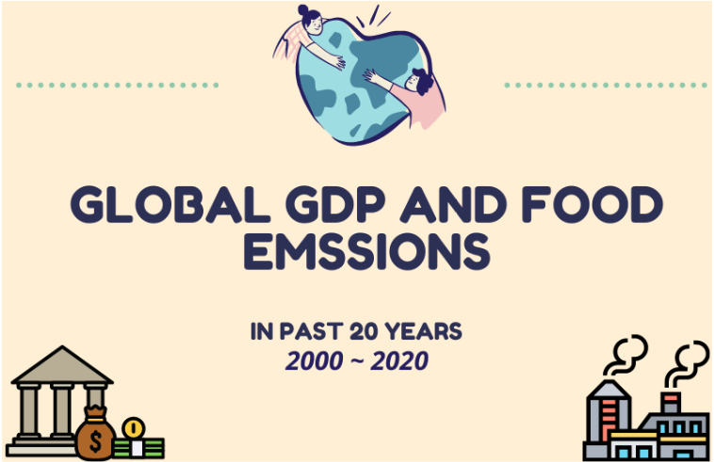

Figure 16. Infographic cover page

**Correlation between Top 3 GDP countries and carbon (CO2) emissions value**

As shown in Graph.10, top 3 GDP generated countries from the latest 20 years are U.S.A, which is holding the highest GDP value with 19.68%, where China is on the second place with 16.5% and Japan is the third with 5.70%.

From the provided data, the listed three countries are having the highest GDP value out of 264 countries from total. However, the carbon emission generated value from Japan is significantly lower compared to others.

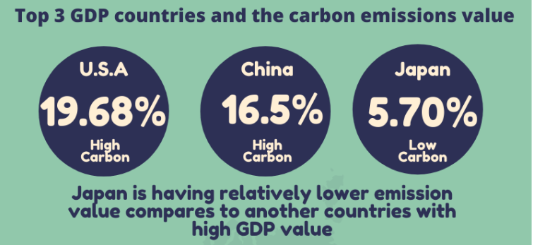

Figure 17. Top 3 countries GDP and carbon emissions info

**Agriculture emission**

For the global agriculture emissions level, China is having the highest proportion rate, where having 40.4% from the overall value, the second is U.S.A with 32.8% and European Union is currently located on the third place with 26.8%.

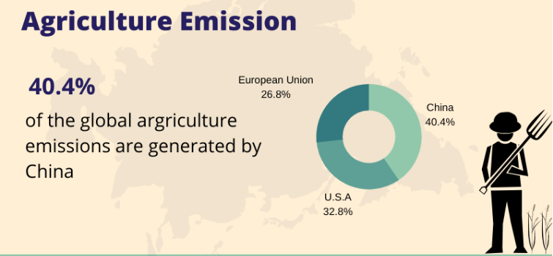

Figure 18. Agriculture emission

**Cattle product emission**

According to the statistic shown in Graph.12 below, the well-known cattle meat-eating culture has giving significant impact on the level of cattle product emissions value.

Where the highest two cattle emissions generated countries are U.S.A with the total emission values have suppressed 200,000,000 and Brazil with 150,000,000, where followed by European union on the third with a little less than 150,000,000 and China is having approximately close 130,000,000 CO2 cattle emissions.

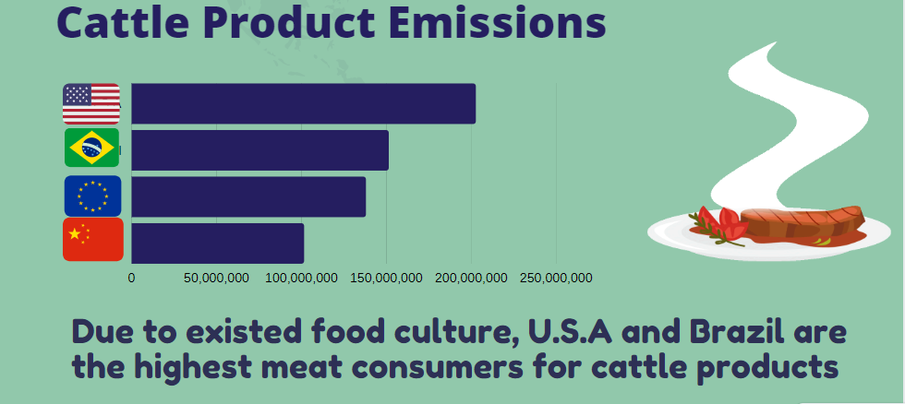

Figure 19. Cattle product emission

**Cereal production emissions**

The current world’s largest cereal production global leader is U.S.A, with the value of 16,791,623,953 tonnes in total. The second production leader is China, with 10,974,384,111 tones and Brazil is located on the third, along with 2,048,169,949 tonnes.

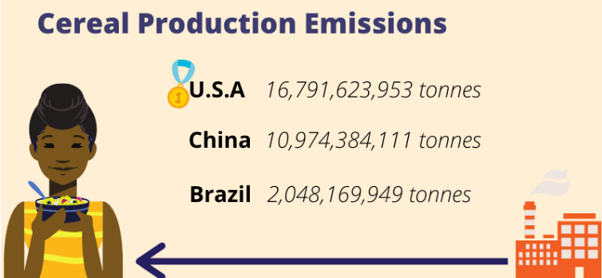

Figure 20. Cereal production emissions

**Rice emissions**

As impact by the popular eating and cuisine culture, the top 2 global rice production emissions generated countries are located in Asia, where China is with 9.67% and India is with 6.57%, along with that, these two countries are the major rice production distributors on the globe.

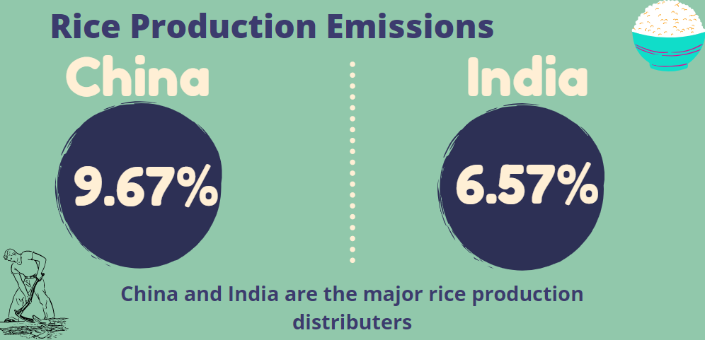

Figure 21. Rice production emissions

**Fresh cow milk production emissions**

According to generated statistics, over 50% of the global milk emissions are generated from European Union, this is because cow milk production is operating throughout all EU regions, this is also an impactful proportion source of European Union agricultural production output. The estimated milk production for European union is 155 million tonnes for each year. The majority producers are located in Netherlands, Germany or Spain etc. (Milk and dairy product, 2016)

Along with the second global highest producer with 20.5%, India with 21.7% and China with 4%.

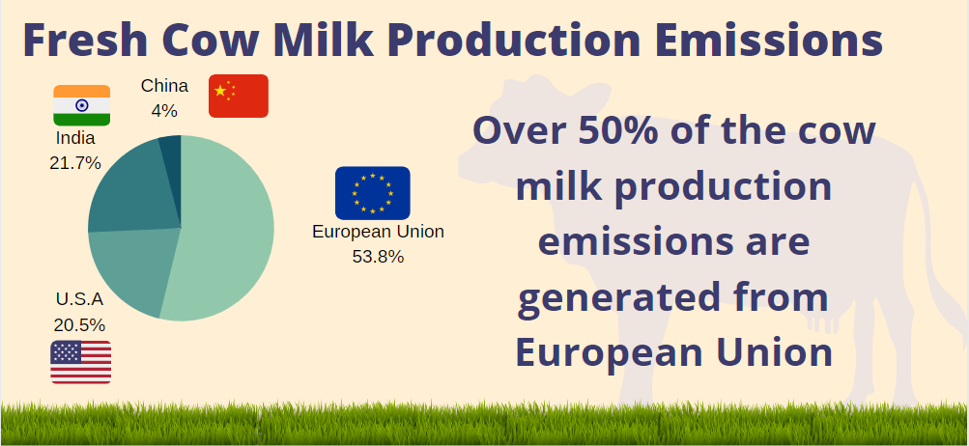

Figure 22. Fresh cow milk production emissions

**Fresh buffalo milk production emissions**

India is the global leader for the market of buffalo milk production, as holding over 80% of the buffalo milk production emissions value.

The underlying of buffalo milk drinking history in India is over hundreds of year in history. According to nutritional benefits, comparing to cow milk, the buffalo milk contains 11% of higher of protein, 40% more in calories, 90% more in fat.

The overall production value is much lower if is produced in large amount. (TNN, 2019)

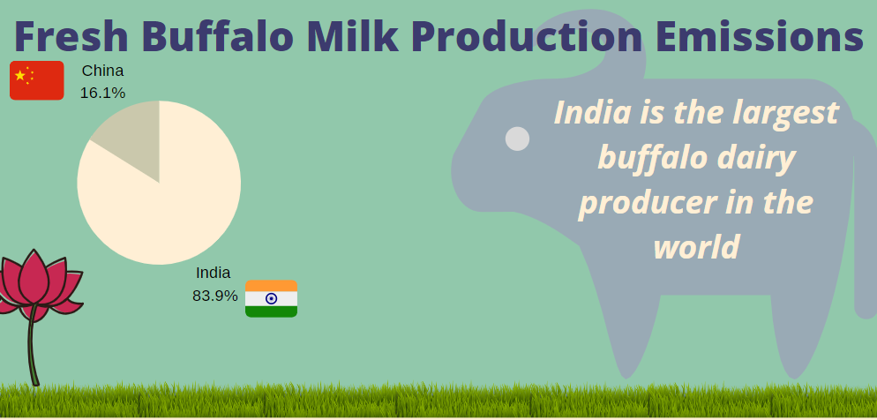

Figure 23. Fresh buffalo milk production emissions

**Eggs related production emissions**

For the recent twenty years, China is the global leader for eggs production, where followed by the second leader European union, and the third from U.S.A.

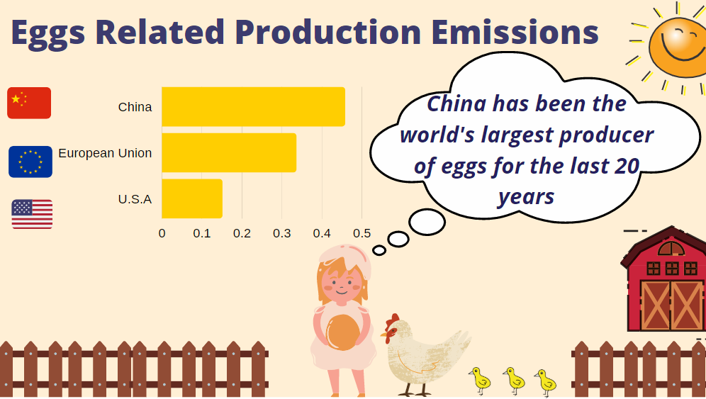

Figure 24. Egg production emissions

**Pork meat production emissions**

According to pork meat production statistics, each (kg) of pork can lead to 6.1 kg of CO2 releasing. The world’s biggest pork meat production market is China, the second is European Union and the third is U.S.A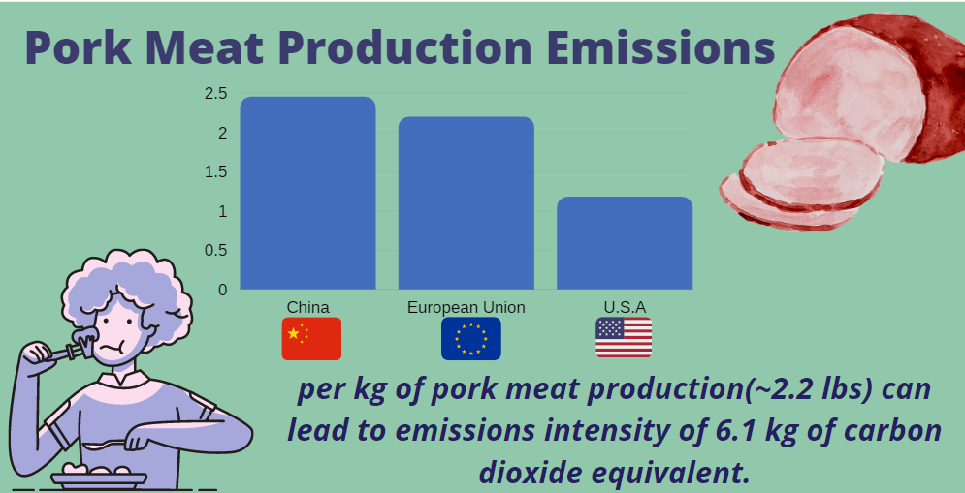.

Figure 25. Pork Meat production emissions

# Bibliography

Cover page material P.1, (Online) Available at:

<https://www.freepik.com/free-vector/global-warming-effect-environmental-conservation-vector_3439692.htm#page=1&query=emission&position=26>

[Accessed:9 August 2020]

Cover page material P.2, (Online) Available at:

<https://www.freepik.com/free-vector/people-suffering-contamination-flat-background_4734186.htm#page=1&query=emission&position=45>

[Accessed:9 August 2020]

The World Bank [online]. Available at:<

<https://data.worldbank.org/indicator/NY.GDP.PCAP.KD.ZG>>[Accessed:1 August 2020]

Food and Agriculture Organisation of the United Sates [online]. Available at:

<<http://www.fao.org/faostat/en/#data/EI/visualize>>[Accessed:1 August 2020]

Global Carbon Atlas [online]. Available at:<

<http://www.globalcarbonatlas.org/en/CO2-emissions>>[Accessed:1 August 2020]

Ritchie, H. and Roser, M., 2020. Environmental Impacts Of Food Production. [online] Our World in Data. Available at: < <https://ourworldindata.org/environmental-impacts-of-food> > [Accessed 8 August 2020].

Worldpopulationreview.com. 2020. Greenhouse Gas Emissions By Country 2020. [online] Available at:<<https://worldpopulationreview.com/country-rankings/greenhouse-gas-emissions-by-country> > [Accessed 10 August 2020].

2016, Milk and dairy product, (Online) Available at:

<https://ec.europa.eu/info/food-farming-fisheries/animals-and-animal-products/animal-products/milk-and-dairy-products_en>

[Accessed:12 August 2020]

TNN, 2019, Cow milk vs. buffalo milk: Pros and cons, (Online) Available at:

<https://timesofindia.indiatimes.com/life-style/health-fitness/health-news/cow-milk-vs-buffalo-milk-pros-and-cons/photostory/69464498.cms>

[Accessed:12 August 2020]

Farm report, 2019, Indian dairy big but still traditional, (Online) Available at:

<https://www.dairyglobal.net/Farm-trends/Articles/2019/2/Indian-dairy-Big-but-still-traditional-392228E/>

[Accessed:10 August 2020]

Z.Yang, 2019, egg production in China, (Online) Available at:

<https://www.cambridge.org/core/journals/world-s-poultry-science-journal/article/egg-production-in-china/AD3BE149F9DE4654279211D8FB4830B7>

[Accessed:10 August 2020]